**The Code Crusader's Survival Guide: Thriving in the Digital Jungle**

In today's ever-evolving tech landscape, coders are the modern-day explorers, navigating a complex digital world. But fear not, aspiring code warrior! Here's your survival toolkit for thriving in the jungle of ones and zeros.

Firstly, embrace the power of lifelong learning. Technology is a relentless force, constantly pushing boundaries and forging new paths. The key to survival is a commitment to continuous learning. Devour online tutorials, attend coding bootcamps, and explore emerging technologies like blockchain or artificial intelligence. Staying curious and adaptable ensures you'll always have the skills to tackle new challenges and navigate the ever-shifting digital terrain.

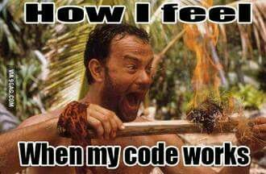

Secondly, build your network. No coder thrives in isolation. Cultivate relationships with fellow developers, both online and offline. Join coding communities, attend industry meetups, and participate in open-source projects. These connections not only provide valuable learning opportunities and insights, but also serve as a support system. When you encounter a bug so baffling it makes you question the fabric of reality itself, having a network to tap into can be a lifesaver.

Finally, remember the power of soft skills. While coding prowess is a given, don't underestimate the importance of communication and collaboration. The ability to explain complex technical concepts in clear language is essential for working effectively with clients, designers, and other stakeholders. Being a team player, a problem-solver, and an effective communicator will not only enhance your projects but also open doors to exciting new opportunities. So, hone your coding skills, nurture your network, and unleash your inner communicator – with these tools in your arsenal, you'll be a code crusader ready to conquer any digital frontier.